Standard view ZB_OTC_SALESORDER

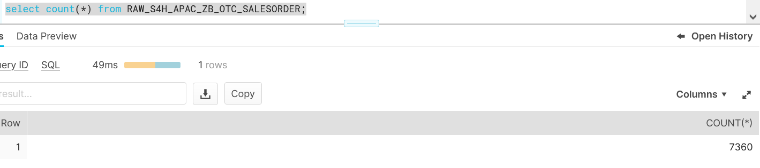

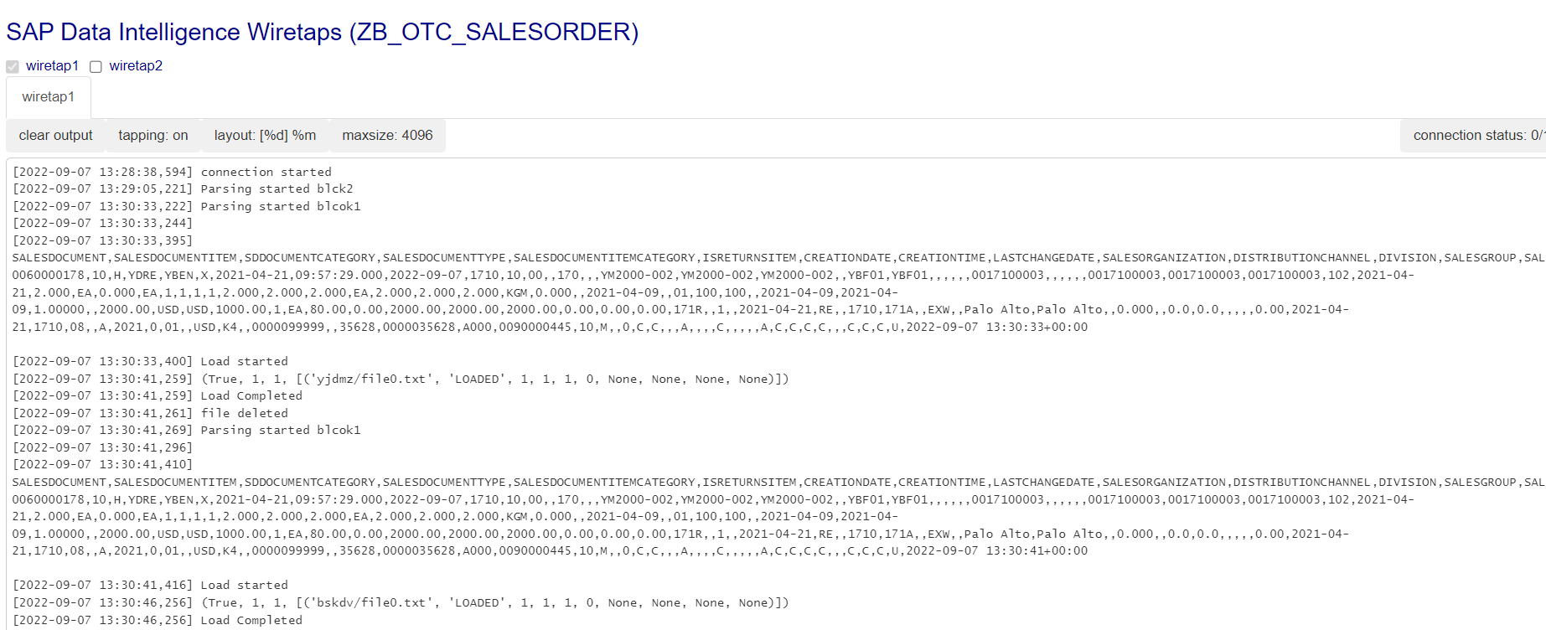

Update and Delete Operation in Standard View

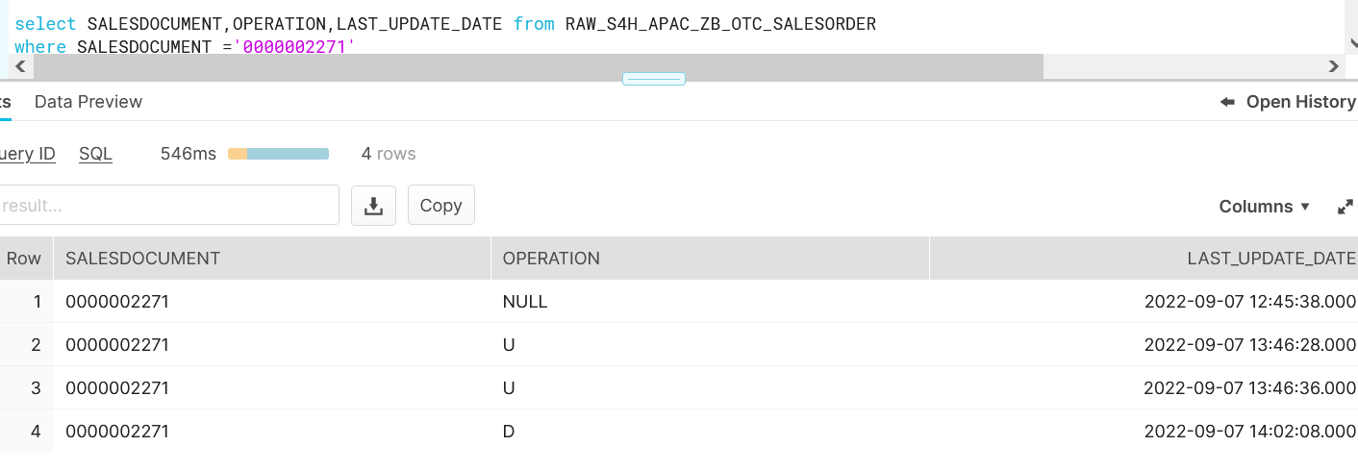

Custom View

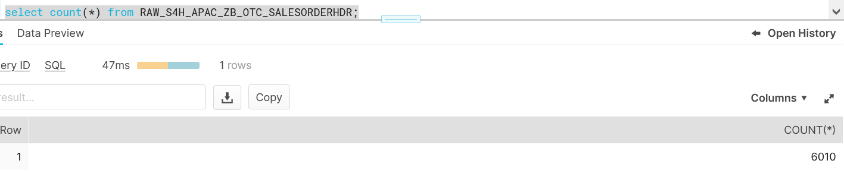

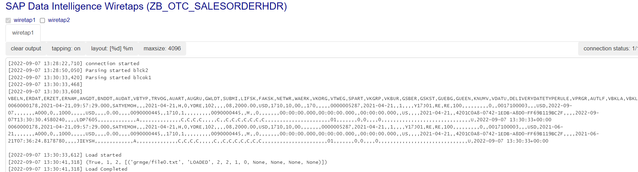

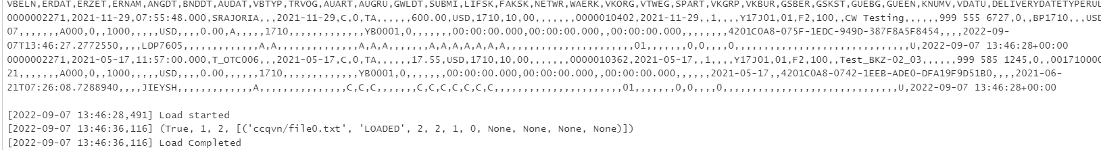

Update Operation in Custom Header view

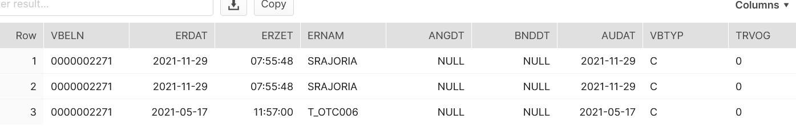

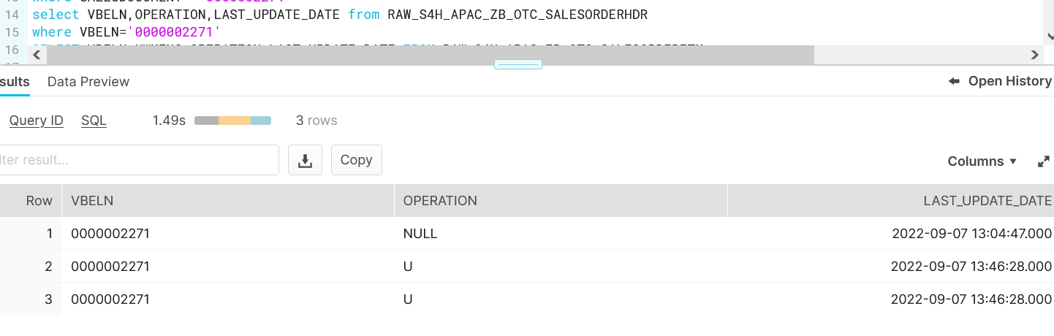

Update Operation in Custom Item view

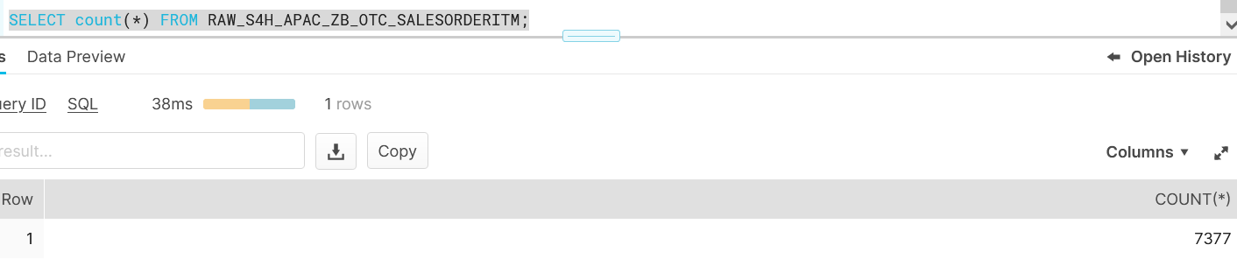

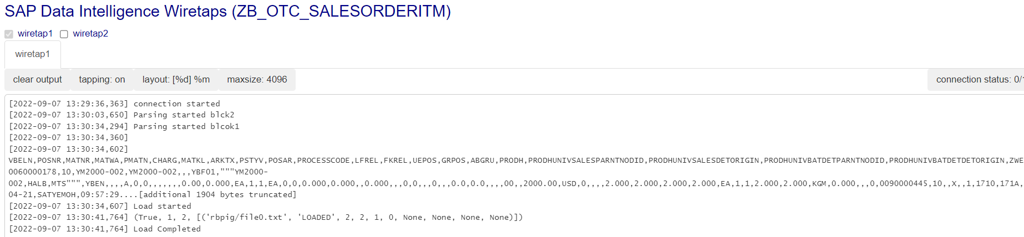



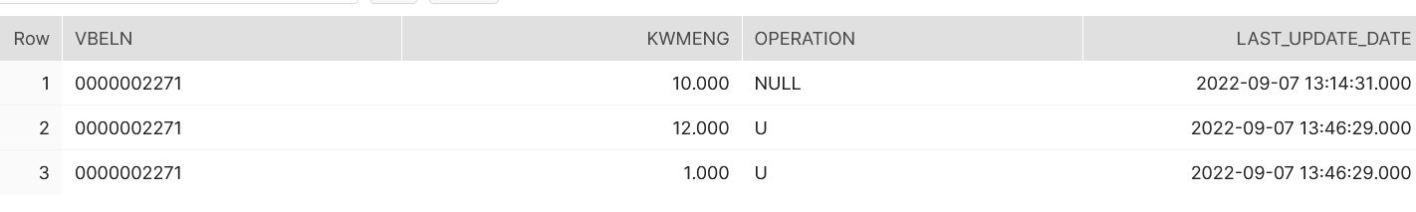

Testing on Customer View.

Standard view Delete Operation

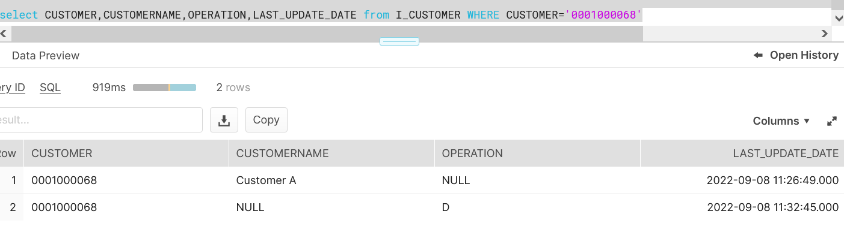

Custom View Delete Operation

